(Approx. 1107 words)

Meet the New Gmail
By Nancy DeMarte, 1st Vice President, Sarasota Technology User Group, FL
October 2018 issue, STUG Monitor
www.thestug.org / ndemarte (at) verizon.net

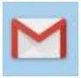
Gmail is a popular email service for good reason. Located in the cloud, it can be accessed from any computer, smartphone, or tablet. Once you get familiar with the interface, it is simple to use. A few months ago, I began to notice little changes to my Gmail screen. Some things were moved; others were new. After a brief search, I found that Gmail is involved in a big makeover which began in the spring of 2018. Gmail users are getting features as they become available, although everyone is not getting them at the same time. Here are a few of the changes that are included:
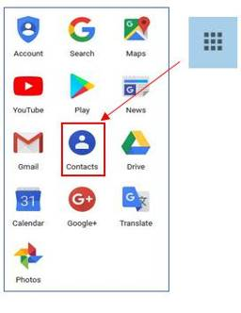

Moves and Changes

- The Contacts list has been moved from Gmail to the center of the Google app grid. Click the grid (top right of Gmail screen) to open it. This change has frustrated users looking to add or edit a

contact. When composing an email, though, Gmail still lists relevant Contacts when you begin to add a name.

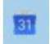
- The Google calendar icon has been added to the right side of the Gmail screen. Now you can add events or reminders to it without leaving Gmail.

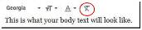
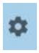
- When composing a message, you will now find four options for text size: Small, Normal, Large, and Huge. To set your personal font, size, and text color, go to Settings (Gear icon > Settings) and find the “Default Text Style” heading. Click the “Remove Formatting” icon (right end of toolbar), then set your preferences using the down arrows. To save changes in Settings, scroll to the bottom of the page and click “Save Changes.
- If you want to forward or reply to all recipients in the new Gmail, skip the reverse arrow in the top right corner of the message. That sets up a Reply only to the sender. Instead, click the three vertical dots icon next to the arrow and make your choice.

New Gmail Main Menu (left side of screen)
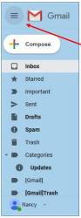

Most of these commands are familiar to anyone who has used Gmail. To save space, however, only the icons are visible until you move your mouse over them. Then the list opens to include the icon names. You can make it stay open by clicking the 3-lined icon in the top left corner of the screen, as shown.

New Gmail Icons & Features (right side of screen)

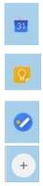
Google uses a lot of icons. The tiniest of them can have the biggest functions. To see what an icon means, hover your mouse pointer over it without clicking, and its name will appear, sometimes with more information. To use one of the features below, click it, and it opens as a right sidebar.

Google Calendar lets you view or edit your calendar without leaving Gmail.

Keep lets you make notes and share them with others.

Use Tasks to create a To Do list and check off items as they get done.

Get Add-ons takes you to the G Suite Marketplace which has add-on features and apps you might like.

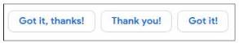

Ten New or Updated Gmail Features – Available Now or Coming Soon

1. Smart Replies: These are canned, informal replies
which appear at the bottom of some emails. When
in a hurry, click one and send it as your reply.
2. Snooze: Snooze lets you remove an email from the Inbox and return it after a
time you set, such as ‘tomorrow’. It is useful for emails that you want to answer
at a later time.

3. Nudge: When enabled, this function will suggest emails that you should reply to
or sent mails to follow up on. Go to Settings to enable or disable it.

4. Confidential Mode: These functions are designed to increase security. You
can set a message to self-destruct at a specific time, or you can send an
email that requires the recipient to enter a code before opening it.

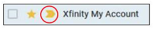
- Importance Markers: Google determines which messages are “important” by putting a gold arrow next to them. In this sample from my Inbox, I clicked the star to show that I also considered it important.
- Smart Compose: This feature is similar to the tablet or smartphone “auto-complete” function. As you type a message, and a few grayed out words complete the thought. If you like these words, just keep typing over them. If not, type something else. You must enable this feature in Settings.

- Labels: Labels (much like folders) are found in classic Gmail but now have new icons. You can create labels (travel, personal, etc.) and put emails into them. Just open an email to reveal the icon group shown. Click the ‘Label’ icon to view the labels list or create a new label. To move an email into a label, click the Label icon, check the box next to a label, and click Apply. Click the ‘Move To’ icon to get extra labels, like Spam or Trash.
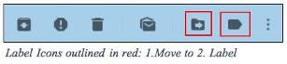

- Offline Support: We know we can’t send or receive email without the internet. But Gmail computer users can now compose, open or read Gmail when not on the internet. The Mobile Gmail version already has this capability.

- Assisted Unsubscribe: This feature targets people who have online subscriptions to newsletters and other regular columns which come via email. If you don’t open one of your newsletters often, Gmail will bring up a notice that lets you unsubscribe.

- Improved Spam Warnings: Gmail has always popped up a notice when you try to open an email known to be unsafe. The new Gmail has larger warnings with colors based on the level of danger. Gray means Suspicious; Red indicates Dangerous.

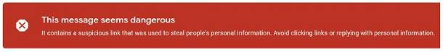

Many of the new features can help you keep your mail organized or save time, but I found a few of them annoying. For example, I’m not sure I want to be “nudged” every time I wait too long to open an email. Fortunately, most features can be enabled, disabled or hidden in Settings. A tip: Don’t ignore the little icons which can be crucial to make Gmail function the way you want it to.

To find out if you already have the new Gmail, open Gmail and click the Settings icon. If the top line says, “Go back to classic Gmail,” you have the new version. You can click that line and return to the old Gmail. Since you can do this at any time, consider trying out the new version for a while before you decide whether to keep it.

